Structural Things
Structural things define the static part of the model. They represent the physical and conceptual elements. Following are the brief descriptions of the structural things.
Class − Class represents a set of objects having similar responsibilities.
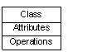
Interface − Interface defines a set of operations, which specify the responsibility of a class.
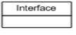
Collaboration −Collaboration defines an interaction between elements.
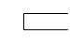
Use case −Use case represents a set of actions performed by a system for a specific goal.
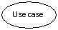
Component −Component describes the physical part of a system.
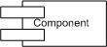
Node − A node can be defined as a physical element that exists at run time.
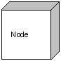

Actor Notation
An actor can be defined as some internal or external entity that interacts with the system.
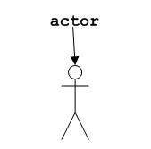
An actor is used in a use case diagram to describe the internal or external entities.

Initial State Notation
Initial state is defined to show the start of a process. This notation is used in almost all diagrams.
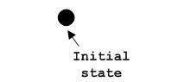
The usage of Initial State Notation is to show the starting point of a process.

Final State Notation
Final state is used to show the end of a process. This notation is also used in almost all diagrams to describe the end.
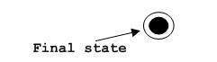
The usage of Final State Notation is to show the termination point of a process.

Behavioral Things
A behavioral thing consists of the dynamic parts of UML models. Following are the behavioral things −
Interaction − Interaction is defined as a behavior that consists of a group of messages exchanged among elements to accomplish a specific task.
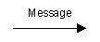
State machine − State machine is useful when the state of an object in its life cycle is important. It defines the sequence of states an object goes through in response to events. Events are external factors responsible for state change
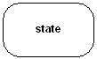

Grouping Things
Grouping things can be defined as a mechanism to group elements of a UML model together. There is only one grouping thing available −
Package − Package is the only one grouping thing available for gathering structural and behavioral things.
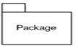

Annotational Things
Annotational things can be defined as a mechanism to capture remarks, descriptions, and comments of UML model elements. Note - It is the only one Annotational thing available. A note is used to render comments, constraints, etc. of an UML element.
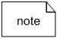

Relationship
Relationship is another most important building block of UML. It shows how the elements are associated with each other and this association describes the functionality of an application.
There are four kinds of relationships available.

Dependency
Dependency is a relationship between two things in which change in one element also affects the other.
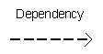

Association
Association is basically a set of links that connects the elements of a UML model. It also describes how many objects are taking part in that relationship.
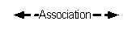

Generalization
Generalization can be defined as a relationship which connects a specialized element with a generalized element. It basically describes the inheritance relationship in the world of objects.
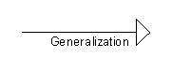

Realization
Realization can be defined as a relationship in which two elements are connected. One element describes some responsibility, which is not implemented and the other one implements them. This relationship exists in case of interfaces.
